Chapter 13

Design Class Diagrams

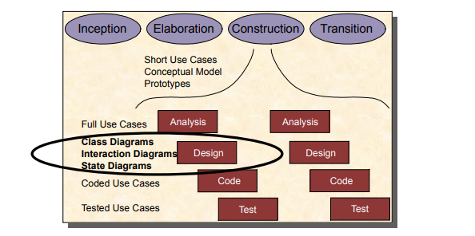

**Preview:**

At the elaboration stage, we built a conceptual model which contained details about the customer’s problem, and concentrated on the customer’s concepts, and the properties of those concepts.

However, those concepts were not allocate behavior.

Now, we can use collaboration diagrams which have been begun to create, and conceptual model to build a true Design Class Diagram ( or Fully Class Diagram)

Aim: We looked at how to progress the class model, based on our work on collaborations

**How to create Design Class Diagram?**

Example: Crediting and Debiting Accounts

*In Conceptual Model*

-The ‘bet’ object sends a message to the customerís ‘Account’ object, to tell it that it must be decremented.

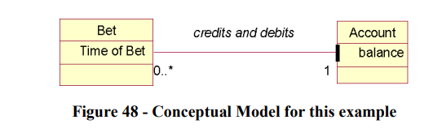

*In Collaboration Diagram:*

-The message was developed with if condition and parameter ‘stake’

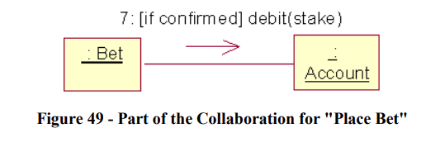

According two informations we can create class diagram of use case ‘Crediting and Debiting Accounts’ with followings step:

Step 1 : Add Operations

Use the message to create operations.

